**Fullstack project:**

**Create a small social network**

**Developer:** Mahajan Nilesh Navnath

[nileshnmahajan@gmail.com](mailto:nileshnmahajan@gmail.com)

9975720525.

**Domain**: web based project.

**Requirements:**

**1.PYTHON3**

**2.python-django package**

**3.JS enabled browser to use website**

**Technology used:**

Python3

Python-Django framework

html, CSS, JS

sqlite3 database

**How to run:**

1.change directory to root of this project where manage.py located.

2. open terminal / cmd and enter command as python manage.py runserver 0.0.0.0:80

Linux need to command as python3 manage.py runserver 0.0.0.0:80

3. open browser and go to http://127.0.0.1

4. First time needs to signup for that click on signup

or

login after signup or already have account.

5.you can search friends add them see there post like comment. share your post.

**Tested on:**

**hardware**

Intel i3 processor

**OS**

windows 10 OS

**Languages**

python 3.7.4

Django 2.2.3

Install Django using pip

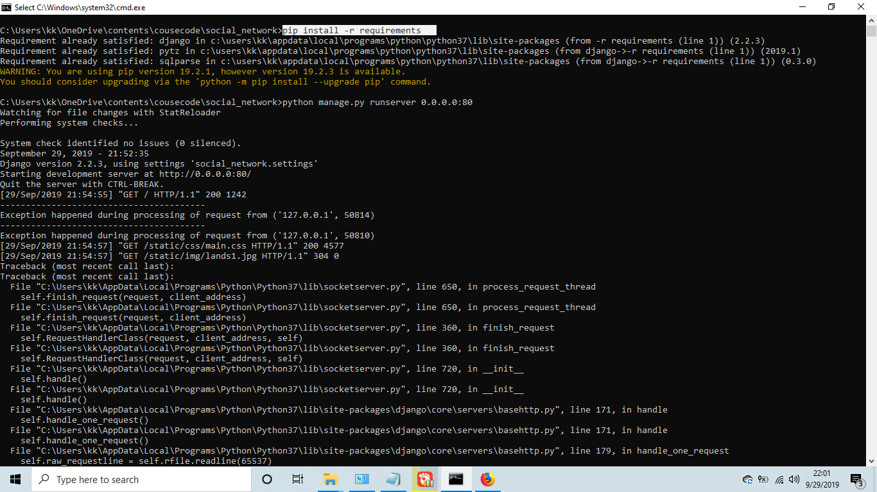

Start server

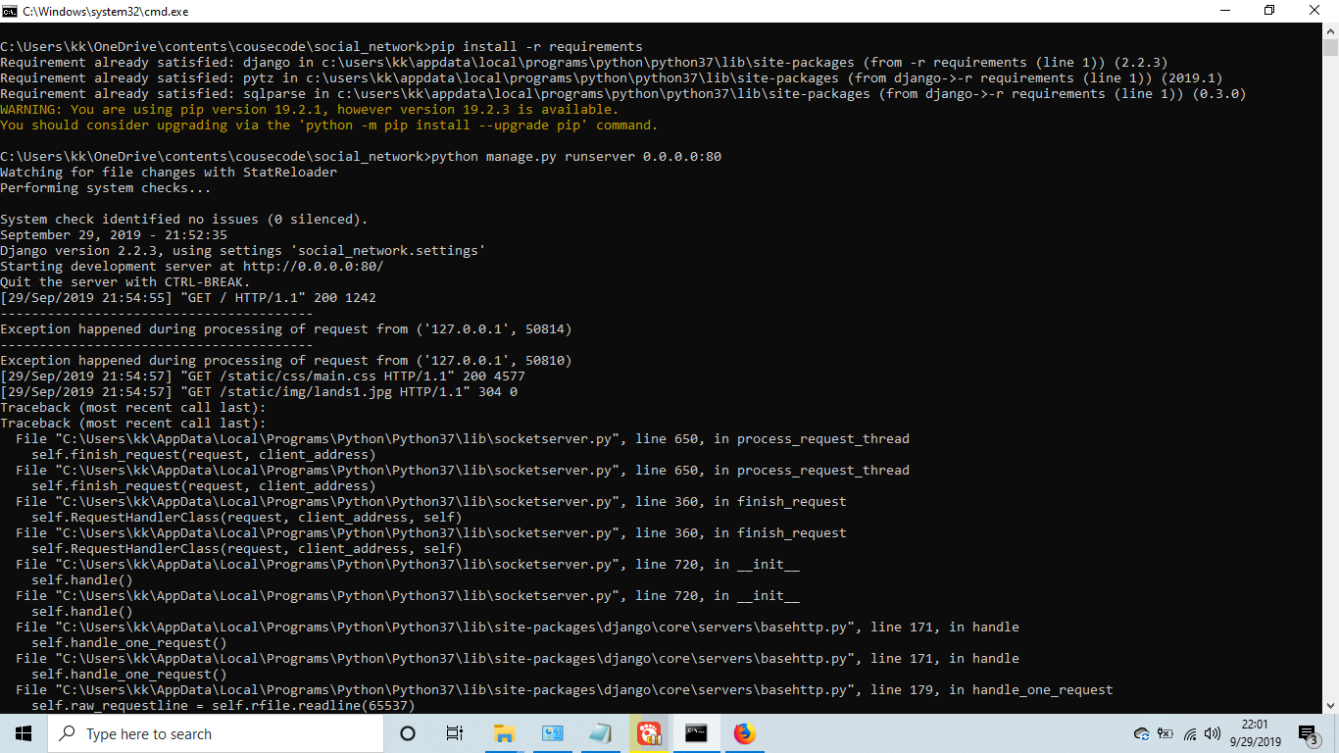

own profile and profile of anotherfriends list and search resultfriend search and search suggestionnew post publishnew post creating and insert imageposts of friend and commentsLOGIN AND SIGNUP**Github repository: https://github.com/nileshnmahajan/social_network/**

